

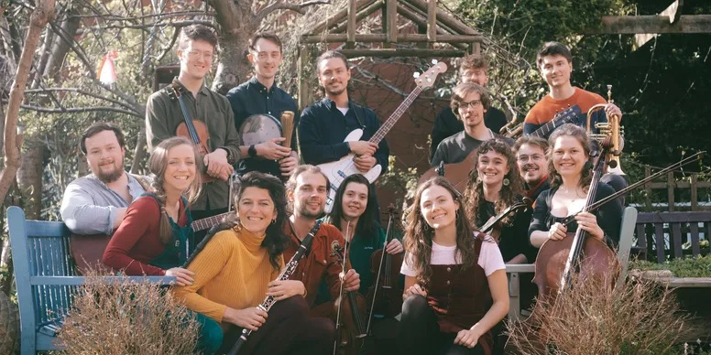

**FILKIN’S ENSEMBLE**

**BIOGRAPHY**

As the sheer joy and energy radiating from the stage combines with a sophisticated musicianship, Filkin’s Ensemble produce a musical experience like no other. In collaboration with singer Ellie Gowers, their distinctive style of "orchestral-folk" forges a new path for traditional music.

The ensemble’s contemporary arrangements of traditional songs combine a string quartet, clarinet, bass clarinet, saxophone, guitars, recorder, and orchestral percussion. This eclectic instrumental lineup joins forces with Ellie Gowers, whose work was described by The Guardian as being ***"full of delicacy, precision and gentle delight"***. Drawing inspiration from classical and jazz, the ensemble presents ***"a powerful display of incredible compositional skills and harmonic design"*** (Bright Young Folk).

Filkin’s Ensemble is the bold vision of Seth Bye and Chris Roberts (aka. Filkin’s Drift) who have recently earned widespread acclaim for an 870 mile foot-powered-tour, with national airtime on **BBC Radio 2, 3, 4, 6 Music, and BBC World Service**. They also achieved global attention from major news outlets including **BBC News, Billboard, The i, Radio New Zealand, Canadian Broadcasting Company, and The Times**. Forming Filkin’s Ensemble in 2020, Seth Bye and Chris Roberts now bring together 14 of the UK’s finest young folk musicians in an adventurous collaboration.

**QUOTES**

***"Hugely entertaining”***

R2 Magazine

***"They create a sound that is truly joyful”***

TradFolk

***"The future of folk music… a truly remarkable band”***

FATEA

***"Full of delicacy, precision and gentle delight”***

The Guardian describes Ellie Gowers’ vocals

***"A powerful display of incredible compositional skills and harmonic design”***

Bright Young Folk

***"An absolute joy to behold”***

Totally Folked

**TradFolk's Young Folk Musicians You Have to Hear 2023**

**LINKS**

filkinsmusic.com

facebook.com/filkinsmusic  
instagram.com/filkinsmusic

youtube.com/@filkinsmusic

*For further information, please contact Ant Miles at Fancourt Music*

*07837 881941 | ant.miles@fancourtmusic.com | fancourtmusic.com/filkinsdrift*